Lab 9 – Code Review and Quality: Using AI to improve code
quality and readability

PROMPT:
CODE:
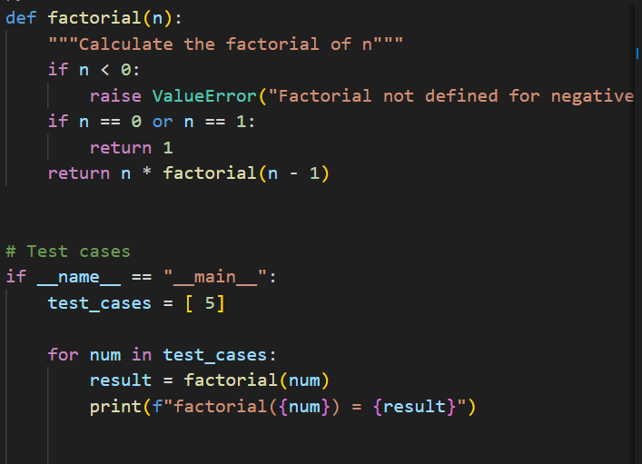
OUTPUT:
EXPLANATION:
The factorial code had an off-by-one error. It skipped multiplying the last number. AI detected the mistake quickly. The loop was fixed using n+1.Edge cases like zero were handled.

Problem Statement 2: Task 2 — Improving Readability &
Documentation

PROMPT:
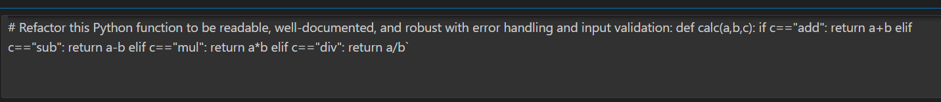
CODE:
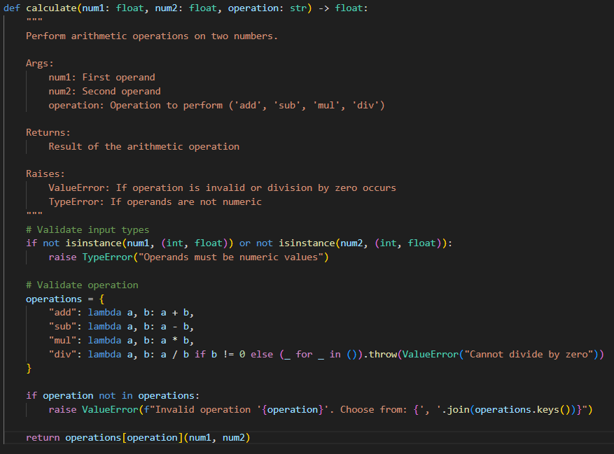
OUTPUT:
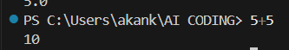
EXPLANATION:
The code had unclear names. AI suggested better naming. A full docstring was added.Errors were handled safely. Code became more readable.

Problem Statement 3: Enforcing Coding Standards
PROMPT:
CODE:
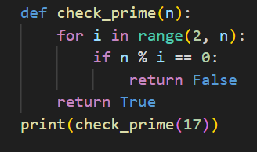
OUTPUT:
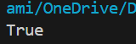
EXPLANATION:
The function broke PEP8 rules.AI listed all violations.Naming and spacing were fixed.Logic stayed the same. Code became standard.

Problem Statement 4: AI as a Code Reviewer in Real Projects
PROMPT:
CODE:
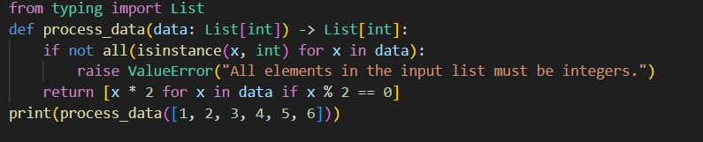
OUTPUT:

EXPLANATION:
The function name was unclear. AI improved clarity and safety. Type hints were added.Logic was generalized. AI helps reviewers

Problem Statement 5: — AI-Assisted Performance Optimization
PROMPT:

CODE:
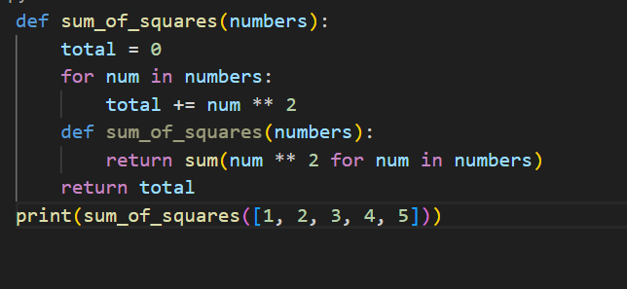
OUTPUT:
EXPLANATION:
The loop was slow for big data. AI analyzed complexity. It used sum() for speed. Code ran faster. Readability vs speed was balanced

